Gender Pay Gap Report - 5 April 2023
Introduction
Our 2022 Gender Pay Gap report follows similar reports that we have produced
under legislation introduced in 2017. This law requires employers with more than 250 employees publish their gender pay gap information every year, and this will be our third annual Gender Pay Gap Report.
This report is a useful measure of the difference between average earnings
for men and women and we use it to understand how we can improve our working practices to reduce our gender pay gap.
Our gender pay gap metrics as at 5 April 2023
The gender distribution for full-pay relevant employees included in this report is 322, 19% male and 81% female compared to 18% male and 82% female for 2022, and 2021 which reported 33% male and 67% female.
After undertaking the gender pay gap reporting exercise for this year running we are pleased to report that we have managed to achieve zero in the median difference of the hourly rate of pay between men and women from -1.11% in 2022 and 2.7% in 2021. We have seen the mean pay gap further decrease to -2.37% from 0.12% in 2022 and 2.5% in 2021. Overall across the organisation this is a very small gender pay gap and very close to 0% which is the target.
The percentage of male employees receiving a bonus was 50.79% (75.41% 2022) and female employees 44.84% (84.56% 2022). The bonus payments for 2022 pay gap report included, in addition to the bi-annual bonus awards, a £10 Christmas voucher, which was not repeated for Christmas 2022 and has resulted in the reduced percentages.
Our workforce has been divided into 4 equally sized groups ranging from the lowest to the highest paid employees. Each Quartile has its own separate pay gap, comparing them shows what levels of pay present any key imbalances.. The lowest quartile is the group that are paid the least, and the highest quartile are paid the most.

- The mean gender pay gap in the lower quartile is 0.33% (3.76% 2022)
- The mean gender pay gap in the lower middle quartile is 0.07% (0.34% 2022)
- The mean gender pay gap in the upper middle quartile is 0.00% (-0.21% 2022)
- The mean gender pay gap in the upper quartile is -1.84% (6.37% 2022)

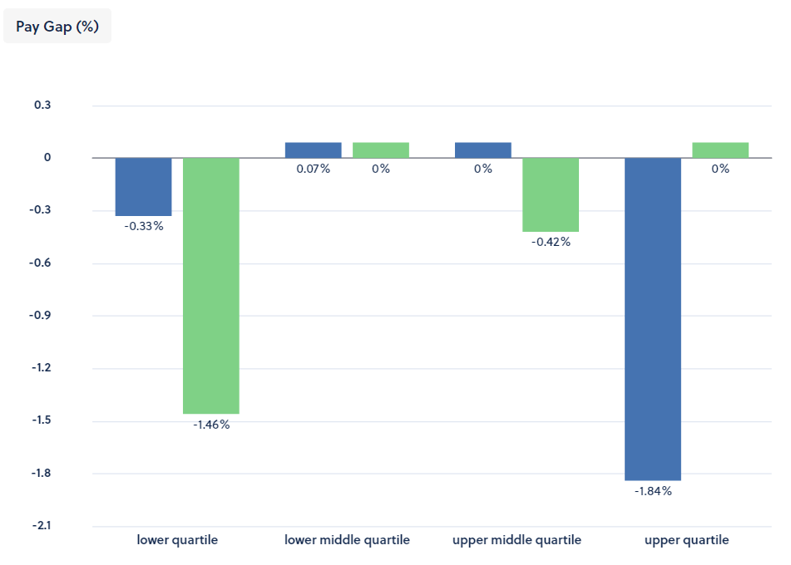
We recognise our largest gender pay gap between men and women is within our upper quartile range. All of our paid colleagues are currently reported as either male or female, and our current make up means that we have an overwhelmingly female workplace with 81% of our people are reported as female, and only 19% as male. In the year after our 2021 report, a number of male colleagues from every pay band have left our charity. Because we have substantial female representation at all levels in our organisation, with very few men joining us, there is a knock-on effect in our data.
We know that the charity sector in general is insufficiently representative of the people they serve, and we are committed to enabling recruitment processes that are as inclusive as possible.
We write adverts, job descriptions and person specifications that focus on the objective skills and experience required by our clients. We discuss, in detail, the objective essentials of the jobs we advertise, ensuring that no copy or verbal brief is potentially discriminatory.
We target candidates irrespective of gender, age, ethnic or national origin, religion, sexual orientation or disability and are clear that applications from anyone who meets objective criteria are welcome.
All stages of our recruitment process are designed to proactively target eligible applicants from all sections of the community, encourage applications from suitable individuals and ensure that candidate selection is based on the skills, ability and experience of the applicant to perform the job. This is measured against objective criteria and competencies that are made available to all applicants.
Our website makes clear that:
We welcome applications from all of the communities in which we work. We also positively encourage applications from people with mental health problems to apply for a role within Solent Mind. Appointments are made on merit.
To maintain our small gender pay gap we must continue to benchmark all salaries externally to ensure our compensation is fair, competitive, and reflects our charitable status. We follow the principle of fair pay, so the salaries our people receive are fair for the job they do and in line with the external job market.
We continue to review and manage the span of our pay grades to provide greater equality for people undertaking the same or similar roles at the same level.

End

